Testing Directions
To begin the test you will need to log on to the NWEA website. This works best in the Google Chrome browser if you are using a Windows computer. Some features will not work correctly from Internet Explorer.
Prior to Testing Day
We suggest that you try to access the link above prior to the test session just to make sure you can utilize the program. If your student would like to have a preview of the format they can take the practice test located at the bottom of the page. This is not graded but it will allow them to manipulate the tools they will be asked to use during the test. Below you will find the login information for the practice test.
https://test.mapnwea.org
Username: grow
Password: grow

Troubleshooting if your screen display seems to be incorrect:
The minimum required screen resolution is 1024x728 with the browser se to full screen and no zoom. Change the device display in the setting menu and, if needed, the browser display. If you continue to have problems please call Ken in our office at 714-8880.

Testing Day
Step 1:
Please be ready to access the testing website about 5 minutes before the testing window. You will need to login using the following information:
As you begin to prepare for your testing session please make sure there will be no distractions. Students may take a short break if needed but please be cognizant of the time away from the test as the program will “time out” if there are extended periods of inactivity. Students may have a blank piece of scratch paper and a pencil during the test. Once your student is ready to begin please read the statement below as you are the proctor for the testing session.
After your student has signed in there may be a short delay while the test administrator confirms your student and the test begins. If your student has not been confirmed within 3 to 5 minutes please contact the Connections Office. Once the test begins, the student may use the tools available within the test or the scratch piece of paper. Students may not seek help from others, reference materials, or tools such as calculators, rulers, etc. If your test session locks up or is unable to continue, please contact the Connections office. At the completion of your test, please exit the testing program and closer the browser. Please email or call your advisor when you have completed your test. Your advisor will be in contact with you to discuss your test scores and seek input about your testing session. Thank you for will to be a part of our test pilot so that we can better meet the needs of our students and families.

Step 2:
https://test.mapnwea.org
Session Name: (sent to you in an email the day of the test)
Session Password: (sent to you in an email the day of the test)
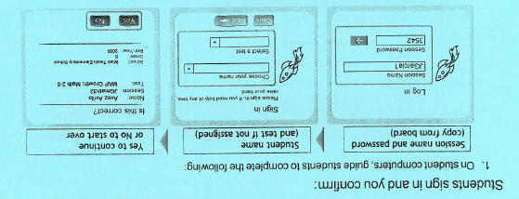
Parents please verify Parents please verify
this is your student this is your student

Step 3:
Parent Please Read Aloud Before Your Student Begins
Give your best effort on this test. It is a chance to show how much you know. We can use it to choose what you are ready to learn next. This is not a timed test, so it’s important to take your time to understand each question before answering. Some questions will be easy, and others will be more difficult. It’s okay not to know all of the answers. If you are not sure how to answer a question, then ask yourself which answers are definitely wrong, and choose from the other answers. Read every question and try your best.
Before you finish a question, you may change your mind and pick a different answer. But, once you move to the next question, your answer is locked, and you cannot go back to the question you have already answered.
I’m here to help if there is a technical problem with the test or if we need to contact an advisor because the test tells you to slow down.

If you encounter questions during the test, please contact the Connections Homeschool office at 714-8880 immediately.

